Menton – Activities and Events

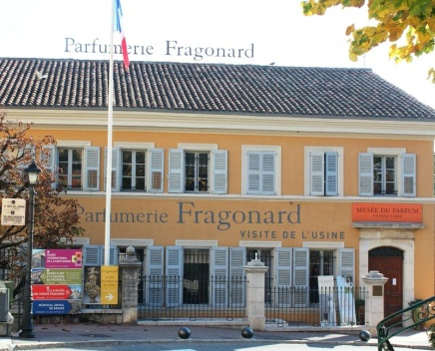
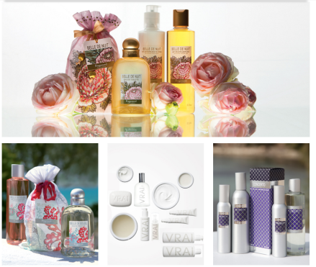
Perfume creation

Fragonard
30 min from Menton
0033 (0) 4 92 42 34 34
fragonard@fragonard.com
06131 GRASSE CEDEX

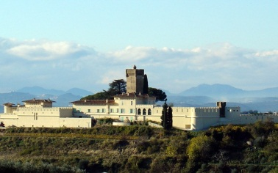

Wine tasting
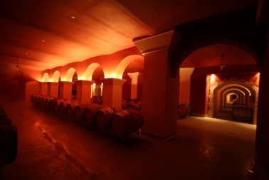
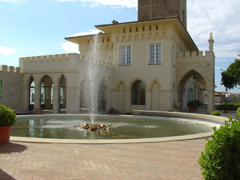
CHATEAU DE CREMAT - AOC BELLET
40 min from Menton
SCEA CHÂTEAU DE CRÉMAT
442, chemin de Crémat
06000 NICE
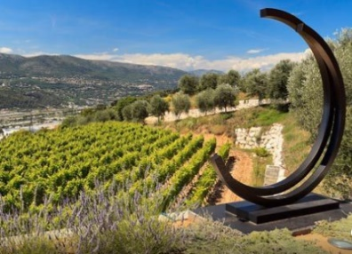
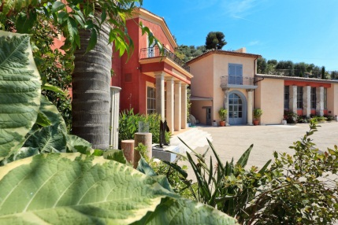
Tél. 33 (0)4 92 15 12 15
Fax.33 (0)4 92 15 12 13
chateaucremat@orange.fr

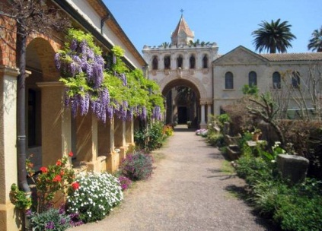
DOMAINE DE TOASC
40 min from Menton
213, chemin de Crémat
06200 NICE
Tél. 33 (0)4 92 15 14 14
Fax.33 (0)4 92 15 14 00
contact@domainedetoasc.com

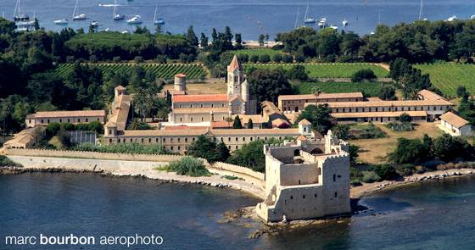
DOMAINE DE L'ABBAYE DE LERINS
1h30 from Menton
Ile Saint-Honorat
CS 10040
06414 CANNES
Tél. 33 (0)4 92 99 54 24
Fax.33 (0)4 92 99 54 41
commercial@abbayedelerins.co

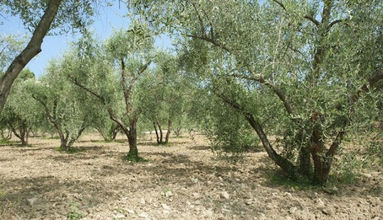
Olive oil tasting

Le Moulin d'Opio
1h from Menton
2, route de Châteauneuf -
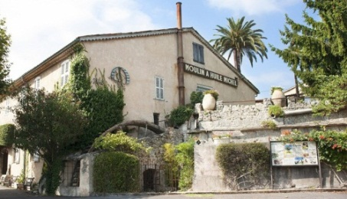
06650 OPIO – FRANCE
Tel. +33 4.93.77.23.03 - Fax +33 4.93.77.39.17
accueil@moulinopio.com

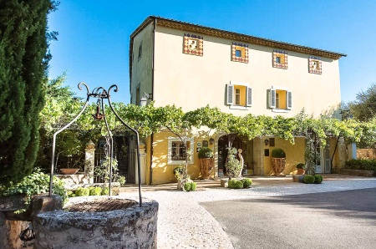
LA BASTIDE SAINT-ANTOINE *****
1h from Menton
48, avenue Henri Dunant
06130 GRASSE
Tél. 33 (0)4 93 70 94 94
Fax.33 (0)4 93 70 94 95
info@jacques-chibois.com

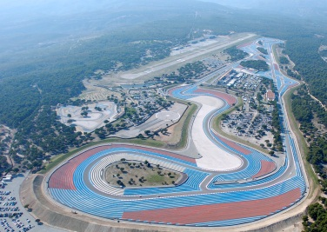
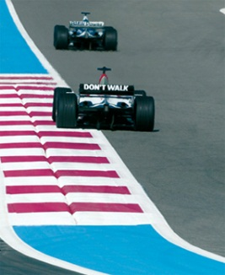
Race cars

Le castellet - Circuit Paul Ricard
2h30 min from Menton
RDN8 2760 Route des Hauts du Camp
83 330 Le Castellet
FRANCE
+33 (0)494 983 666
circuit@circuitpaulricard.com

Museum
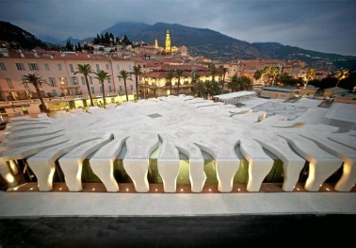
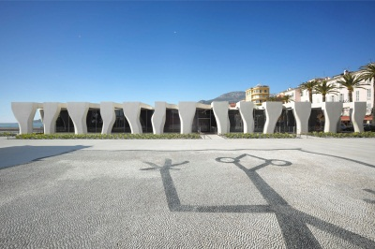
Musée Jean Cocteau
Collection Séverin Wunderman
2, quai de Monléon - 06500 MENTON
mairie@ville-menton.fr
+33489815250

Restaurants

Dine out in style at the 2 Michelin star restaurant Mirazur in Menton

http://www.mirazur.fr/

Special Events
OCT 7TH 2017 – Paul Ricard Circuit – Le Castellet
REEBOK SPARTAN RACE
Reebok Spartan Race is back in Circuit Paul Ricard on October the 7th of 2017 and offers you, for the first time, to race by night for it to be even more challenging and self-surpassing!
Each edition is unique, the Super and Sprint layouts between car track and scrubland offer an amazing view on the sea. 3 trails embellished with both constructed and natural obstacles. Run, jump, climb, crawl, all the competitors' strenghts and energies must be on hold !
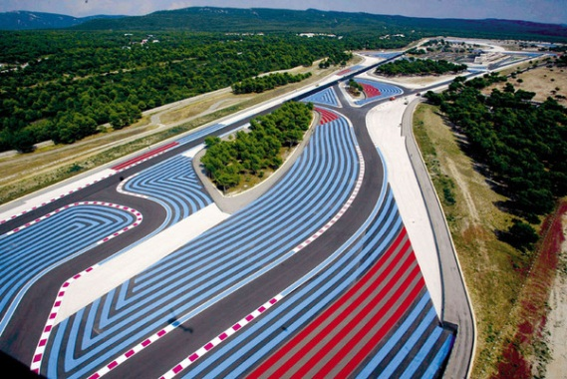
This season, engage yourself on the first Spartan Sprint by Night - a european premiere ! Alone or with a team, come and take up the challenge, be on the strating block once the sun has set and discover a brand new path enlighted by you headlamp in the night's silence.

Menton
The picturesque village of Menton boasts a sensational location and the perfect mild, sunny climate (the warmest on the Côte d'Azur) that allows citrus fruits to flourish. The most atmospheric part of Menton is the Old Town, which has a distinctive Italian ambience. Visitors can begin a tour along the Montée des Logettes and the narrow rue Longue, passing the town's ancient fortifications. A flight of steps (Rampes de Saint Michel) leads up to the Place de la Conception terrace with its spectacular views of the sea. On the left stands the 17th-century Parish Church of Saint Michel with a winged altar created by Manchello in 1569. Further up is the Eglise de la Conception, built in 1685 in the Italian Jesuit style. For those in search of seaside relaxation, the Plage des Sablettes is a wonderful attraction. Those interested in seafaring can visit the Musée Jean Cocteau at Menton's harbour. The village also has a museum featuring works by Chagall, Dufy, and Picasso among others. Another highlight of Menton is its beautiful garden, Jardin Biovès, filled with exotic trees.

Nearby areas of interest

Monaco

30 minutes from Menton

Gorgeous and glittering Monaco is a tiny royal principality on the French Riviera. Less than two square kilometres in size, it is perhaps the most glamorous little stretch of land on the planet. There is a seductive quality to the scenery, with its deep blue sea, graceful palm trees, and vibrant flowers. The most dramatic feature is the steep, rocky promontory jutting out into the Mediterranean, called "Le Rocher" ("The Rock"), which contains historic Monaco, also known as Monaco-Ville. Full of charming, narrow streets, Monaco-Ville dates back to the 13th century when the principality was founded.

A place of sublime natural beauty, Monaco has the lush vegetation and balmy weather of the Côte d'Azur. Considered to have Europe's highest per capita income, Monaco exudes an air of extravagant wealth, as seen in the upscale hotels, designer boutiques, luxury yachts, and opulent restaurants.
Highlights include Monte-Carlo, Palais du Prince, Musée Oceanographique, Monaco Cathedral, Jardin Exotique, Les Jardins Saint-Martin, Opéra de Monte-Carlo (Salle Garnier), Monaco Harbour, Nouveau Musée National de Monaco, Princess Grace Rose Garden, Collection de Voitures Anciennes (Collection of Vintage Cars) and Jardin Japonais.

Monaco is famous for its fine dining and the most renowned is Le Louis XV restaurant, which boasts three Michelin stars and features the cuisine of Alain Ducasse. Second in line is Joël Robuchon Monte-Carlo with two Michelin stars. Le Vistamar has one Michelin star and offers cuisine focused on seafood served on a terrace overlooking the sea. A collaboration between Joël Robuchon and Takéo Yamazaki, Yoshi is a contemporary Japanese restaurant with one Michelin star.

www.visitmonaco.com

Nice

40 minutes away from Menton

The old town of Nice is a charming maze of alleyways and cobblestone streets with colourful fruit, vegetable and flower markets. There are plenty of museums to visit, amongst them the Chagall museum, the only one worldwide dedicated to the artist as well as the Matisse Museum, the Musée des Beaux Arts and the Modern Art & Contemporary Museum in the heart of the City. Other highlights are the Promenade des Anglais, Colline du Château (Castle Hill), Monastère Notre-Dame-de-Cimiez, Jardin Albert I and Cathédrale Orthodoxe Russe Saint-Nicolas.

http://en.nicetourisme.com

Villefranche-Sur-Mer
45 minutes from Menton

A picturesque natural harbour with a waterfront lined with cheerful Italianate buildings, and a dock filled with sailboats. Rolling hills planted with olive groves surround the village, and the microclimate is so mild that tropical fruits such as bananas grow abundantly. The village has a quaint historic centre with a citadel built in 1580 and an impressive church. The Eglise Saint-Michel was built in the town's characteristic Italian Baroque style. By the harbour is the Palais de la Marine and the Chapelle de Saint Pierre des Pecheurs. The Villa Rothschild built in the Italian Renaissance style is situated on the Saint-Jean-Cap-Ferrat promontory and is set in an eleven acre garden of pure enchantment.

http://www.villa-ephrussi.com/en

San Remo
45 minutes from Menton

Sanremo also known as the “city of flowers” has a busy harbour where swanky yachts jostle for space, and old men tinker with more dilapidated marine transport. There are busy shopping streets where you can pick up jewellery and clothes, and a hectic market, where you can pick up bargains. You can walk down the broad palm-lined streets and the old town, the Pigna, named after a pine cone for the way the tight-packed buildings cling to a steep hill.

Highlights of Sanremo include the Russian Orthodox church, the Casino, Museo Civico, Villa Nobel, Old Bussana, Corso dell’Imperatice, Tre Ponti and Villa Ormond.

Antibes
1hr from Menton

Vieil Antibes (Old Town) has narrow, winding cobblestone streets filled with little boutiques, gourmet food shops, cafés, and restaurants. With its seaside views, stone buildings, elegant fountains, and bougainvillea-draped alleyways, Vieil Antibes has the typical character of an old Mediterranean city. The picturesque Cap d'Antibes peninsula and Juan-les-Pins coastline lies on the Golfe Juan extending between Antibes and Cannes boasting 13 public beaches. Highlights include Musée Picasso, Chemin des Douaniers, Musée Peynet, Fort Carré, Cathedral Notre-Dame, Villa Thuret Botanic Gardens, Notre Dame de Bon Port la Garoupe, Villa Eilenroc and the Archaeology Museum.

http://www.antibesjuanlespins.com/en

Cannes
1 hr from Menton

Cannes sparkles with glamour and exclusivity. It has private beaches, marinas filled with luxury yachts, stylish boulevards, elegant Belle Epoque hotels, and fashionable restaurants. Cannes is blessed with a balmy Mediterranean climate with weather that is mild year-round and perfect for sunbathing by the beach from May through October. Leafy palm trees grace the streets of Cannes, and subtropical flowers flourish throughout the city. Highlights include Boulevard de la Croisette, Le Suquet (Old Town), Notre-Dame de l'Espérance, Musée de la Castre, Beaches, Vieux Port, La Californie and Chapelle Bellini.

